In this document, I am going to explain how create a network design. How first step, I install the GNS3 v2 from its official web site, download the ISO image belong to the router 7200 CISCO and import inside the GNS3.

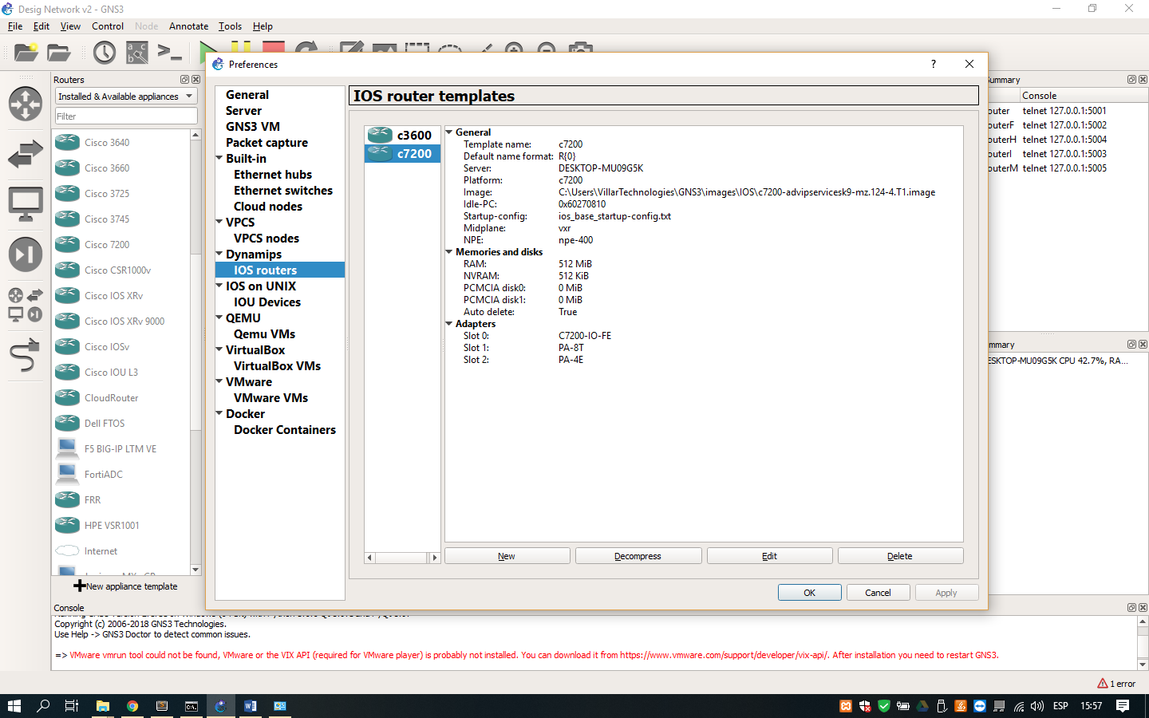

1. Import router c7200 to the GNS3 program GNS3

When the routers are downloaded, we can use it inside the workspace of the GNS3 for make the design.

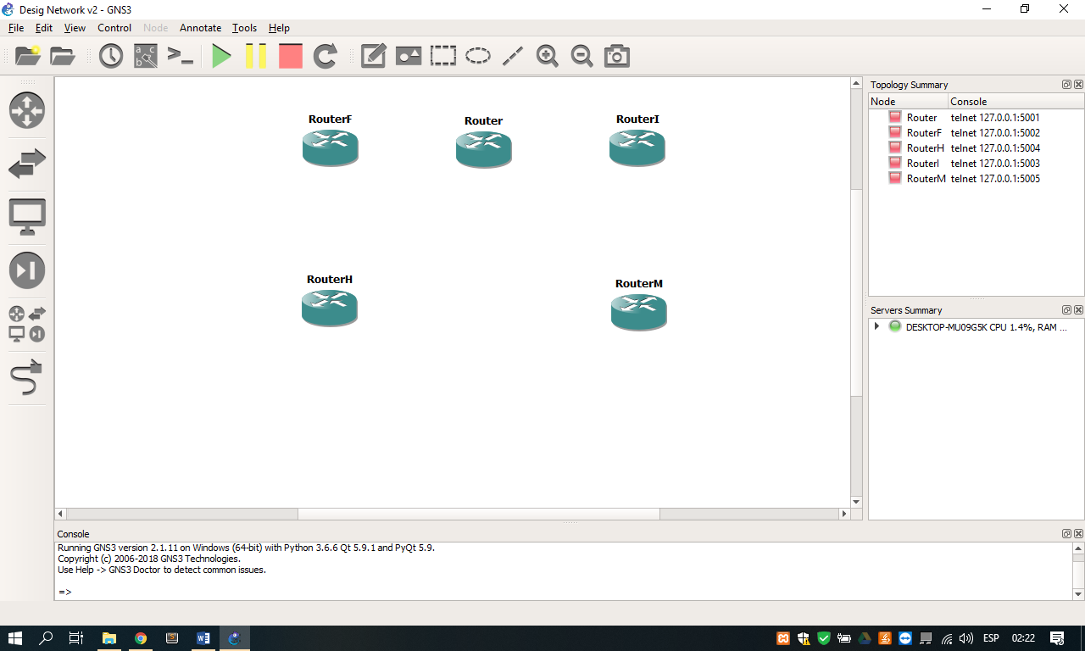

1. Router for use in the workspace

How the routers have to connect each other, we use a serial cable for join them so we configure the slots for this connection as like configure the Ethernet cable for connect the other devices.

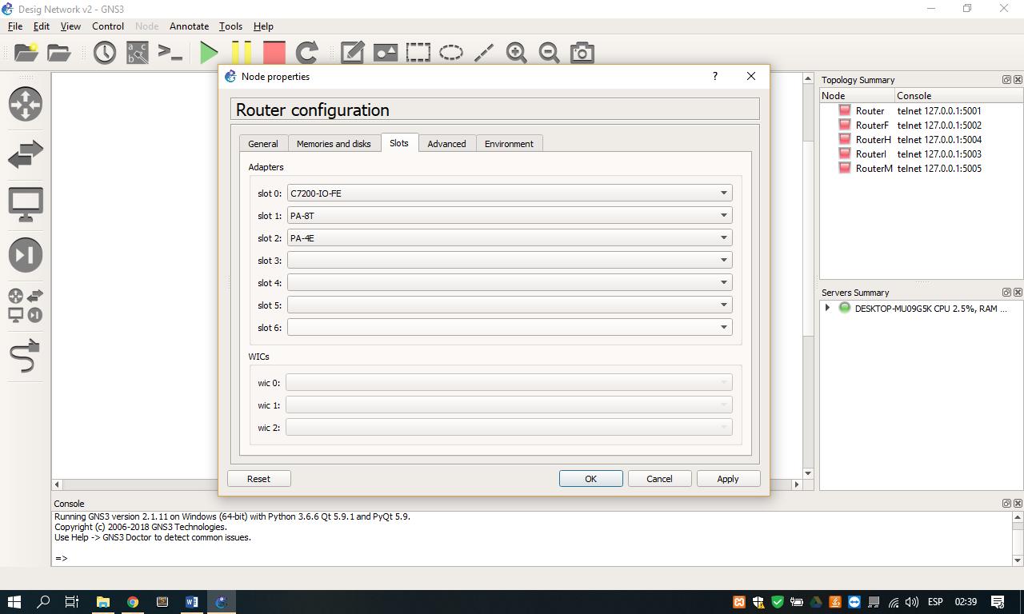

1. View of the router configuration with Ethernet and serial cable

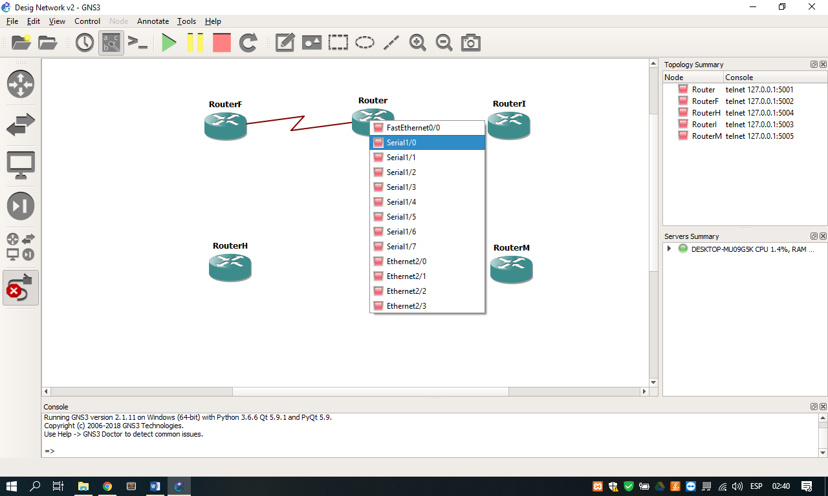

1. Connection of the routers through the slots for serial cable

After of the configuration, we procedure to join the components necessaries for develop the design as switchs, PCs, servers and printers.

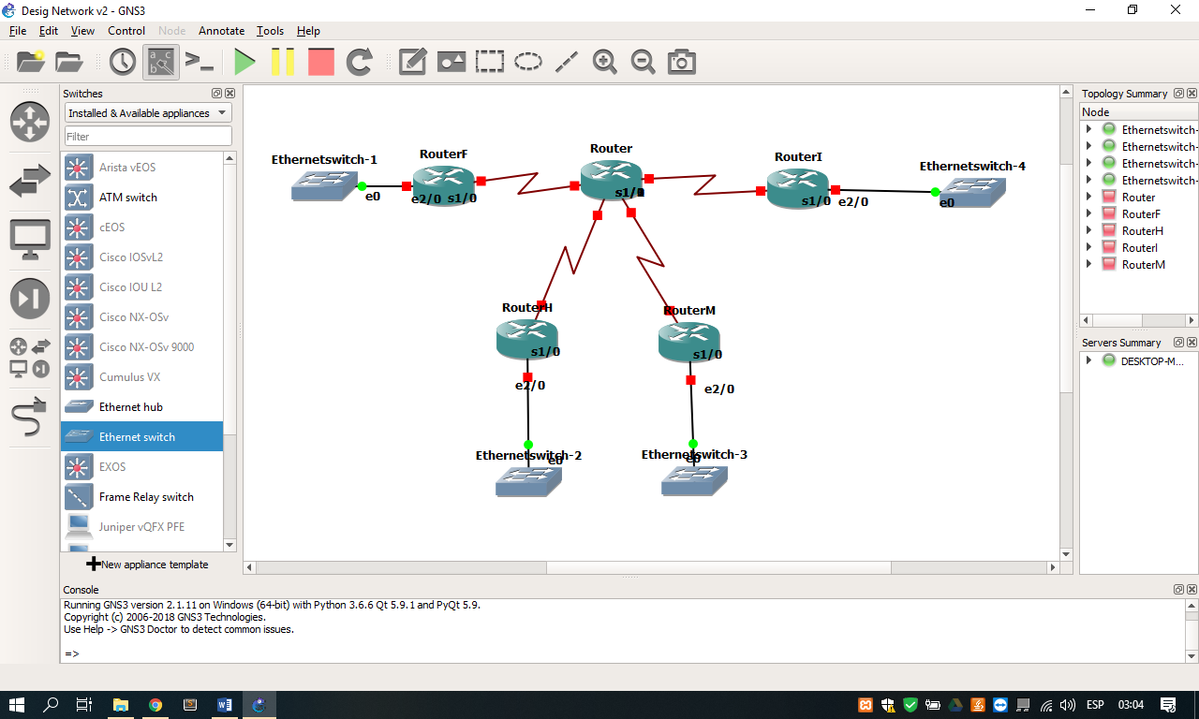

1. View connection with switchs through of ports ethernet

For make the connection existent between the routers of each department with the main router, we will configure an internal network who help to the transition of packages even the hosts request. So, we are going to use the next ip address represented in the table below for its communication.

|  |  |
| --- | --- |
| Points | Network address |
| RouterF – Router (s1/0) | 192.168.0.0/30 |
| RouterI – Router (s1/1) | 192.168.1.0/30 |
| RouterH – Router (s1/2) | 192.168.2.0/30 |
| RouterM – Router (s1/3) | 192.168.3.0/30 |

Table 1. IP address for the connection of the interfaces between the departments and the main router

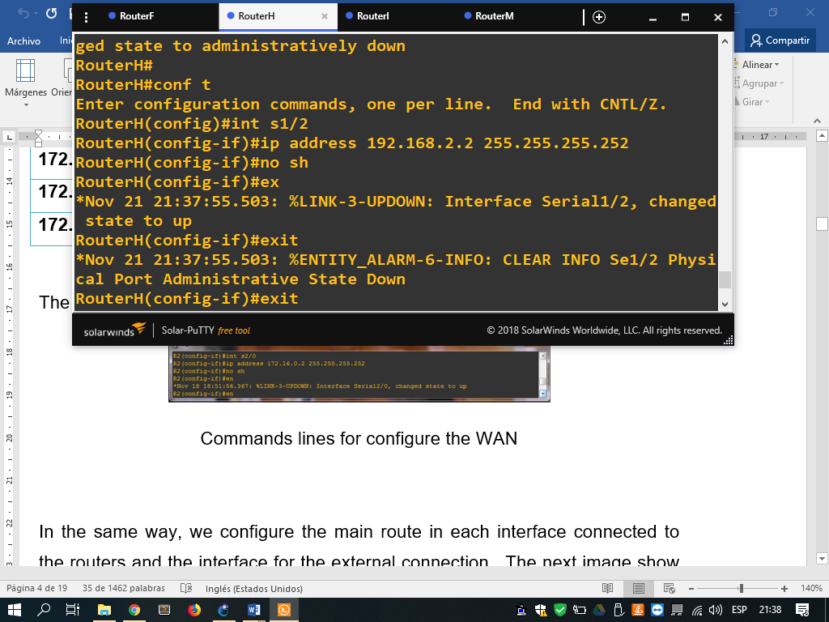

1. Command lines for configure the ip address in the interface of each department router

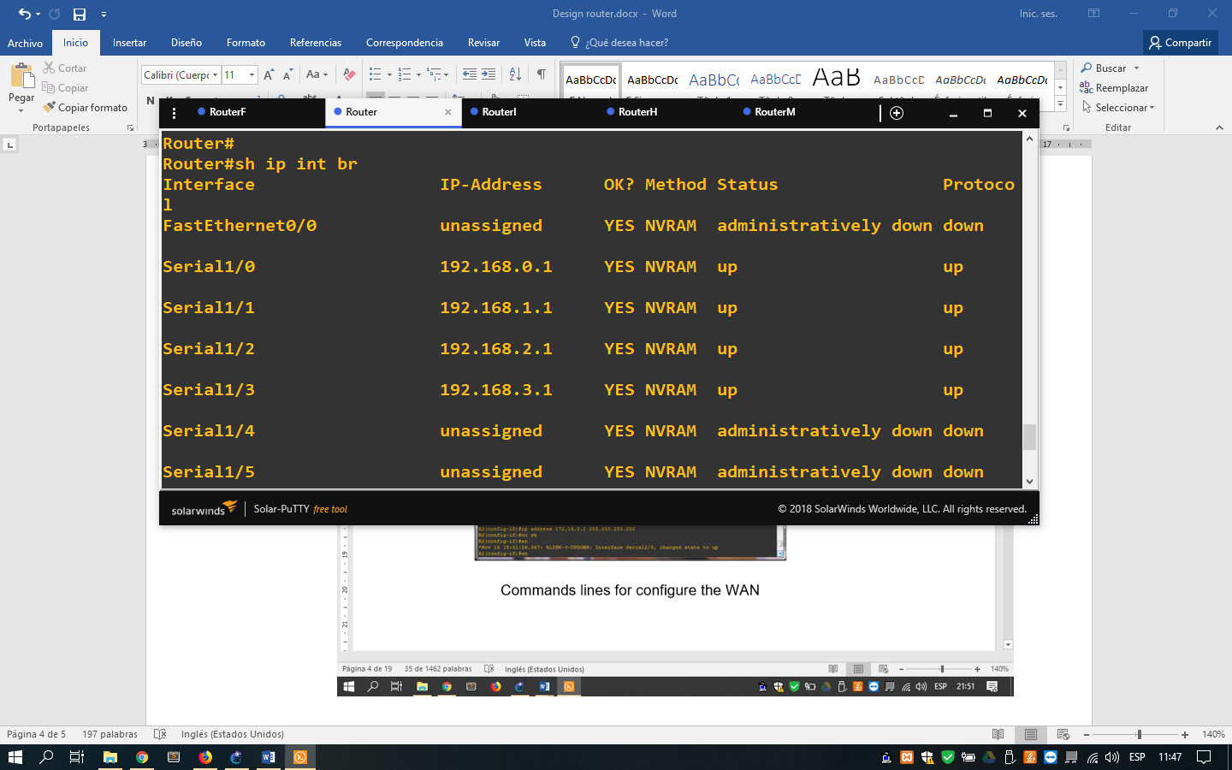

1. Command line for show the interfaces table of the main router

For check the connection between the devices, we make ping from a router until other and obtain a percent of success rate of communication.

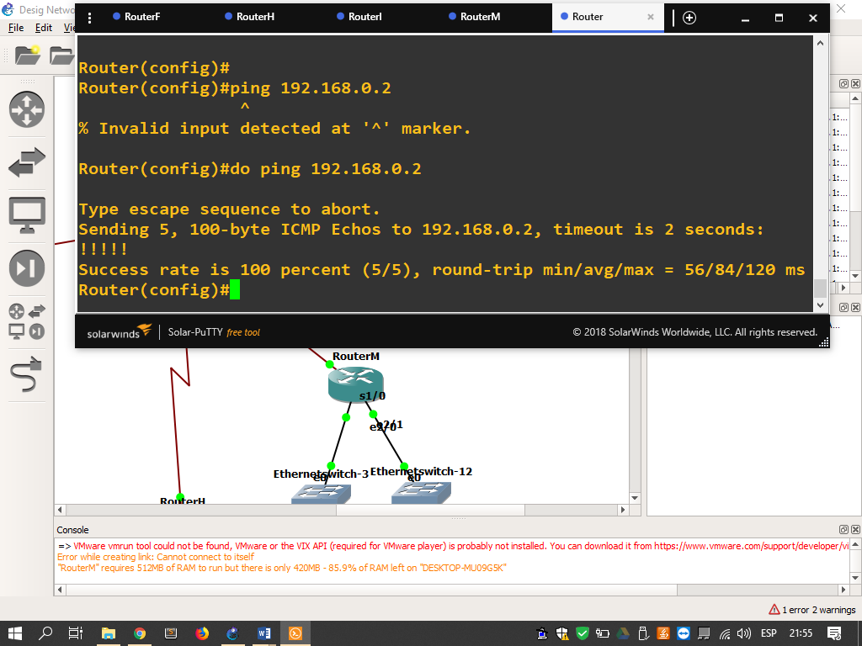

1. Command line for check the connection between the routers obtain a 100 percent

Now we are going to configure the VLAN (Virtual Local Area Network) for create an independent logic network inside our physic network. This configuration will stay inside of the department router and the switches connected it.

The configuration for the switch is on its option “configure” to do right click over it. After, this show us the ports that will be connected to the hosts in our network.

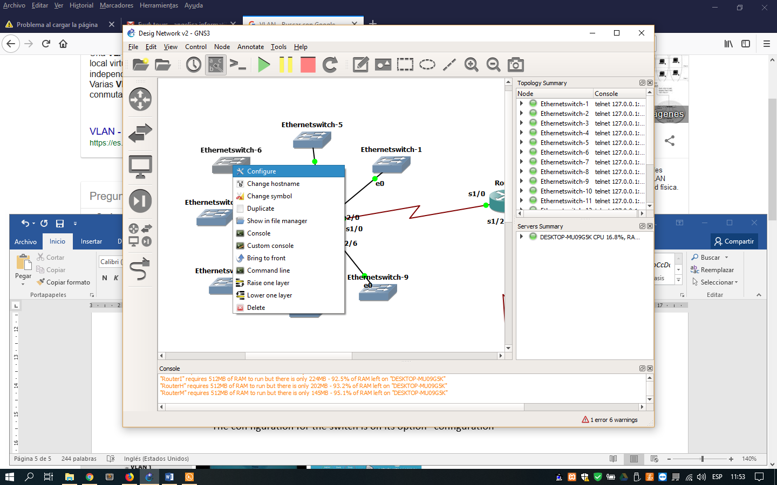

1. View option for the configuration

Each switch will be configured with the necessary number of ports, the first will be the type dot1Q that will allow sharing multiple networks between the same devices without having interference between them; This will connect to the department's router. The other ports will have a VLAN value depending on the department and as a type value it will be access.

The values belong to each department are the showed in the table next:

|  |  |
| --- | --- |
| Department | VLAN number |
| Finance | 100 |
| Information Technology | 101 |
| Human Resources | 102 |
| Marketing | 103 |

Table 2. number of VLAN for each department

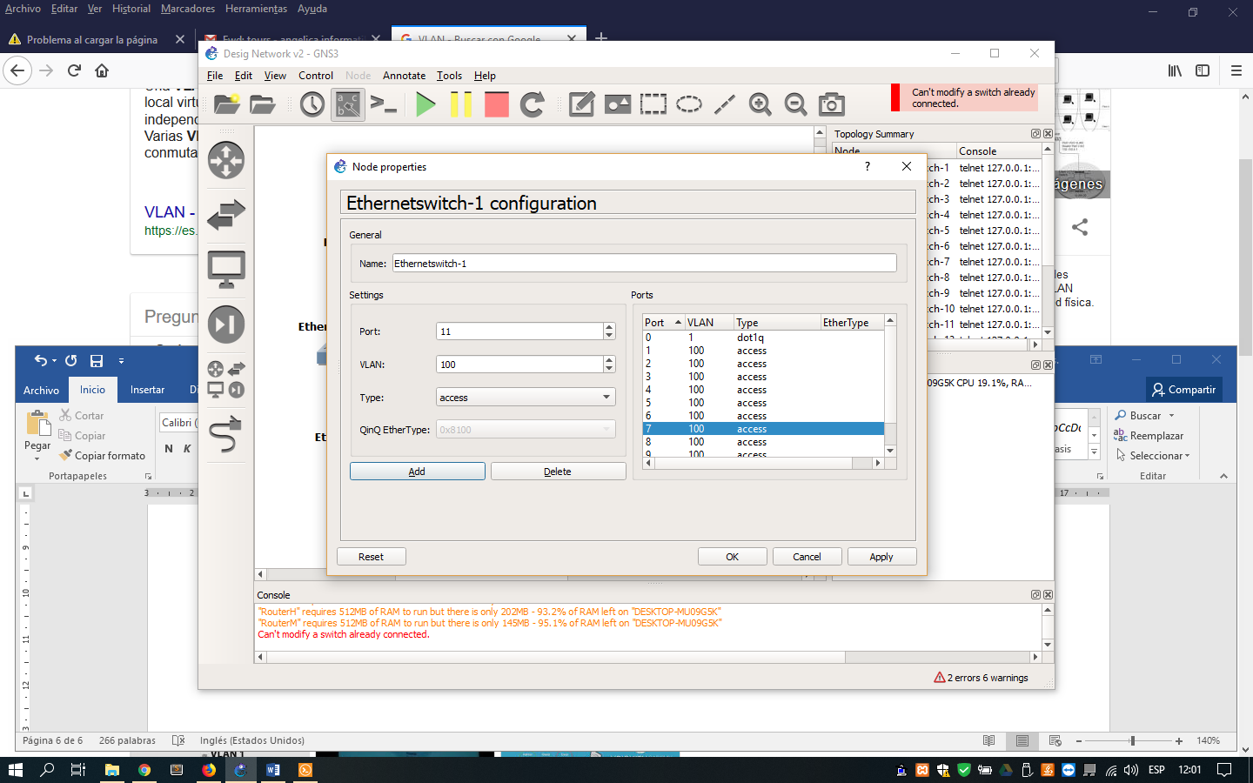

1. Configuration of the VLAN inside of the switch

Inside router console, execute the next command lines for configure the connection with the VLANs for the network:

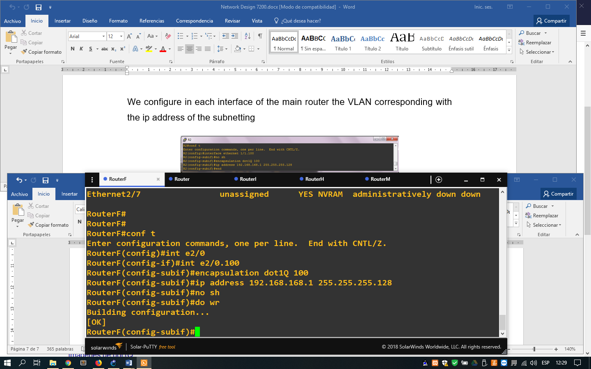

1. Command lines for configure the VLANs for our network

Next the typing the lines, we have the next table with the command line sh **ip int br**, there we can see which interface is assigned.

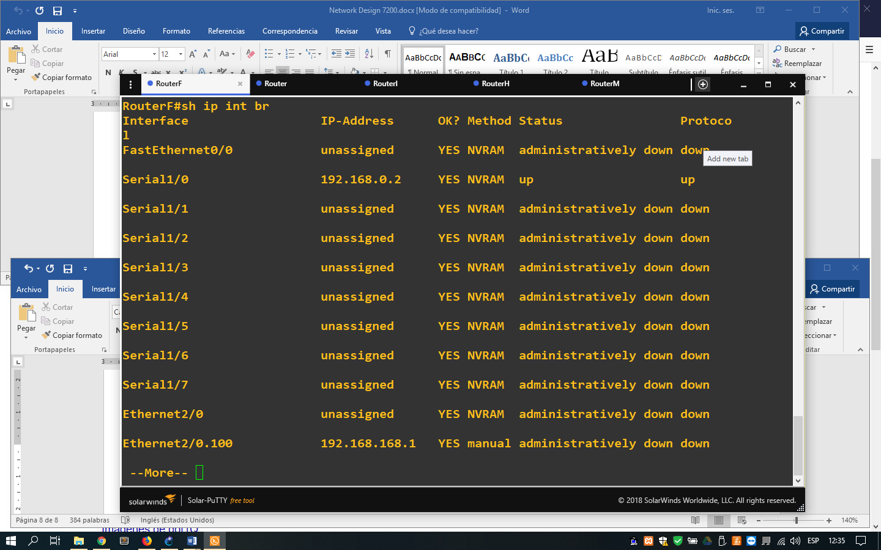

1. Command line for watch the table of the interfaces

The IP address used, was made through of the subneting with the IP private 192.168.168.0/26 using VLSM the next way.

|  |  |  |  |  |  |
| --- | --- | --- | --- | --- | --- |
| Department | Requested host | Network address | Mask | Range usable IPs | Broadcast  address |
| Finance | 69 Hosts | 192.168.168.0 | 255.255.255.128 | 192.168.168.1 - 192.168.168.126 | 192.168.168.127 |
| IT | 39 Hosts | 192.168.168.128 | 255.255.255.192 | 192.168.168.129 - 192.168.168.190 | 192.168.168.191 |
| HR | 19 Hosts | 192.168.168.192 | 255.255.255.224 | 192.168.168.193 - 192.168.168.222 | 192.168.168.223 |
| Marketing | 11 Hosts | 192.168.168.224 | 255.255.255.240 | 192.168.168.225 - 192.168.168.238 | 192.168.168.239 |

Table 3. The information on the IP address belonging to each network

Now for the assignment of the IPs, we put the hosts inside of the workspace and the connect them with a port of the switch. We can change its appearance doing right click over it and clicking on “change symbol”, and appear a window as the next:

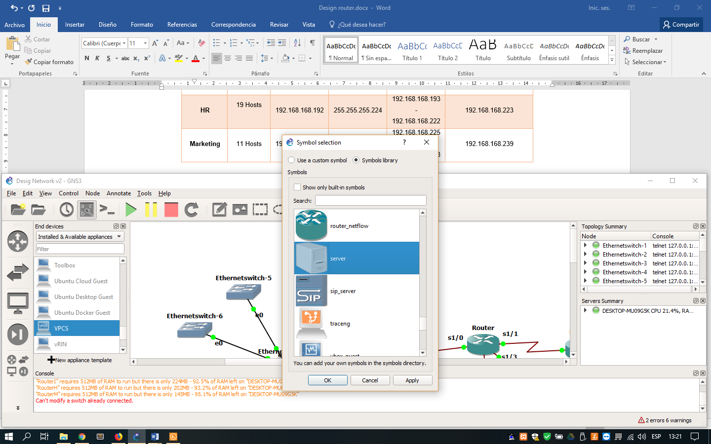

1. View of the window for change the symbol of the host

Inside each department will exist IP static belong to the router, the server and the printer, these will be assignment manually to the hosts (server and printer) of the next way and type save in the end for that it **save** the configuration.

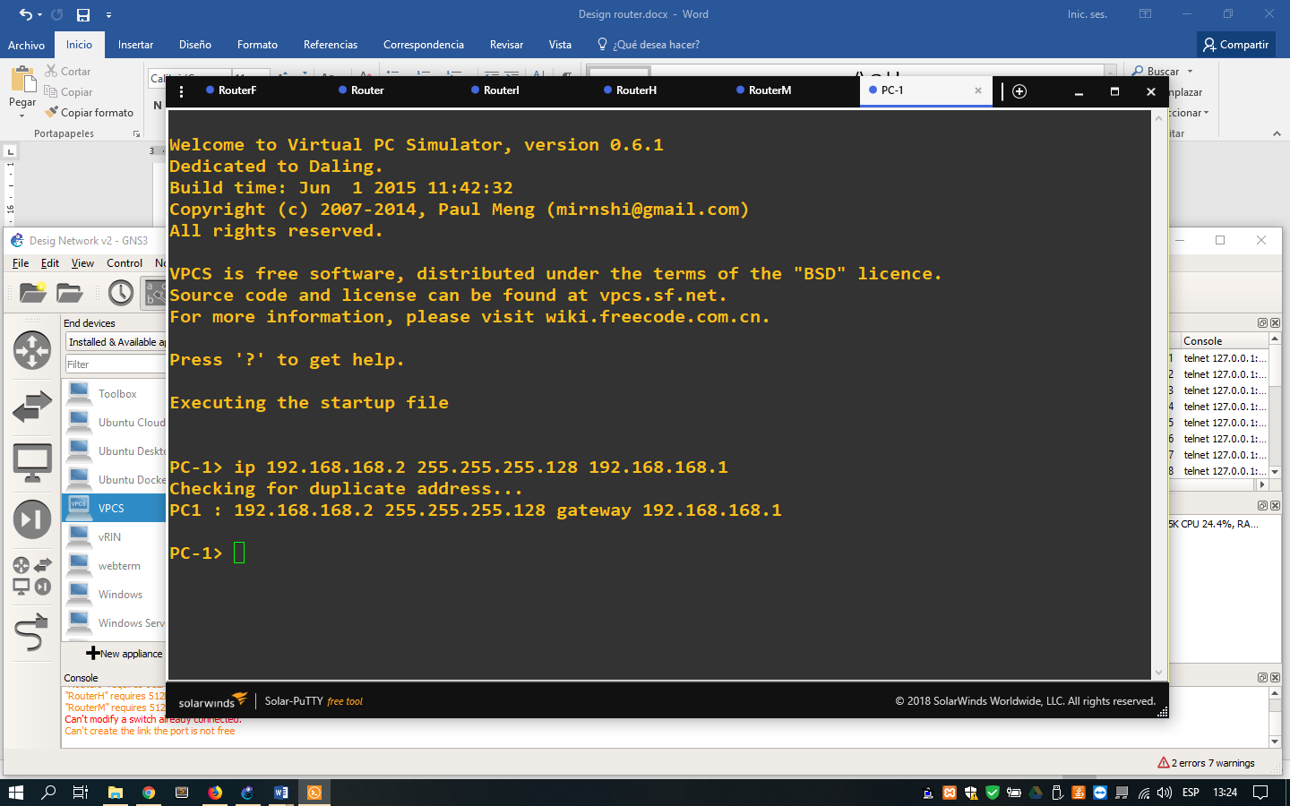

1. Command line for assignment the ip address on the host

And doing ping to the other pc configured, we check that the communication is success.

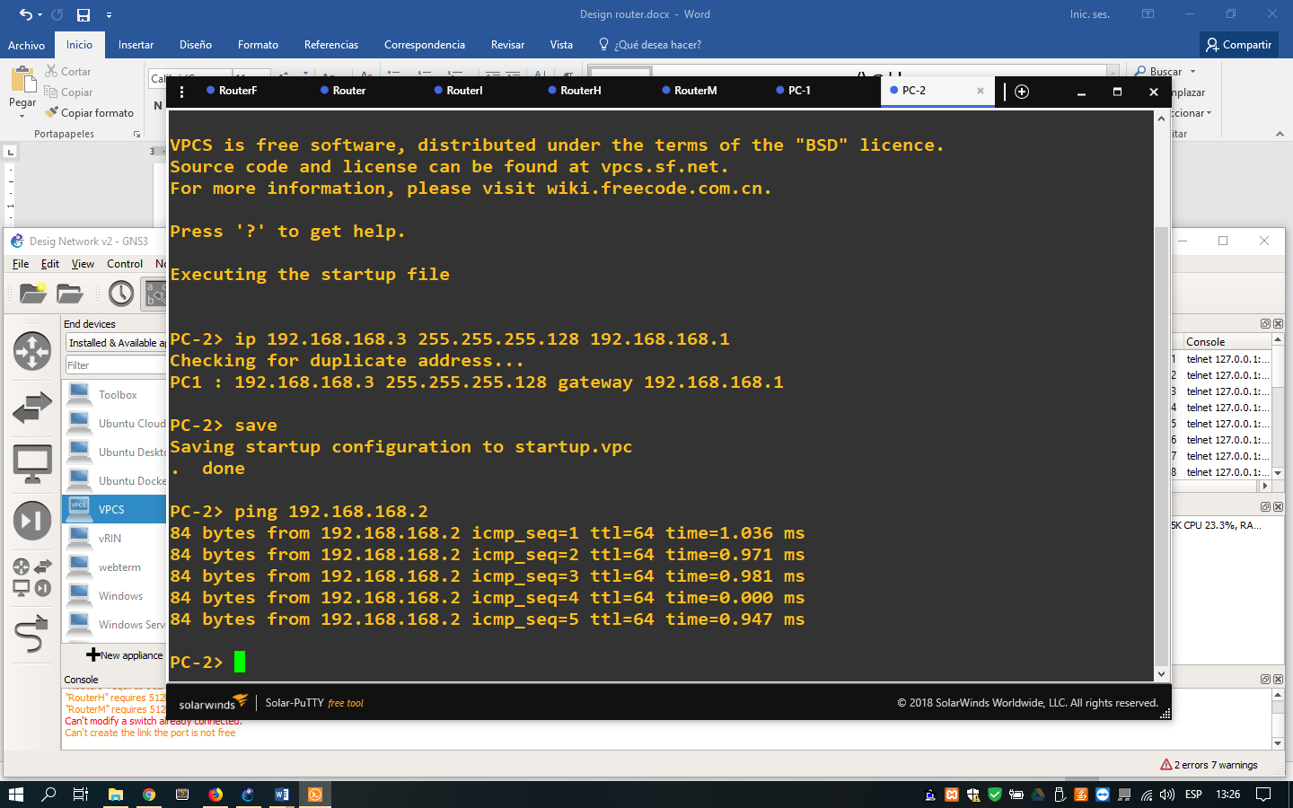

1. Command lines doing ping to other host for check the communication

But as we have many hosts in our network, we can configure a method that we permit assign IP address to the all hosts automatically through DHCP (Dynamic Host Configuration Protocol). This will be configuring it inside the main router of each department with the next command lines:

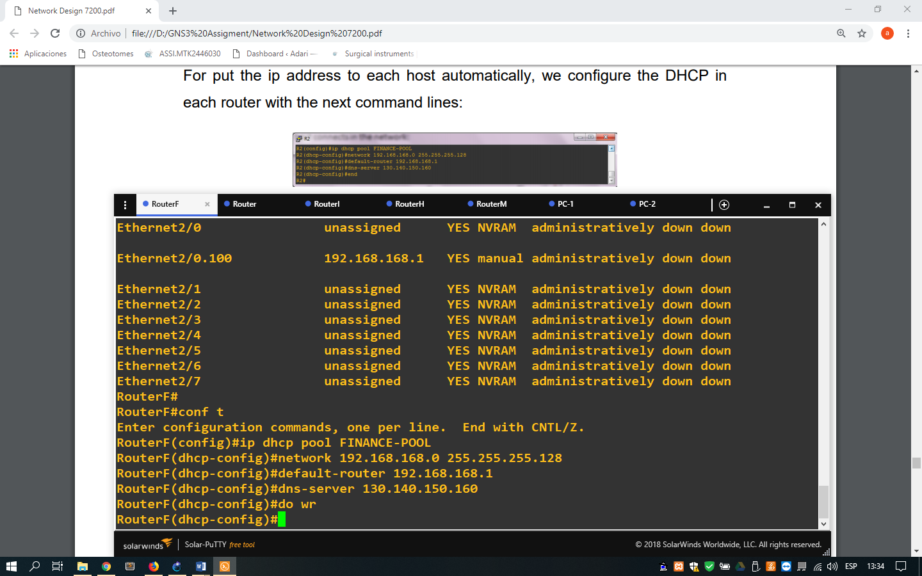

1. Command lines for configure DHCP inside the network

And with the command line, we can have excluded some IPs of the our DHCP for avoid collisions in the moment for assign the IP address in the hosts that have a static IP

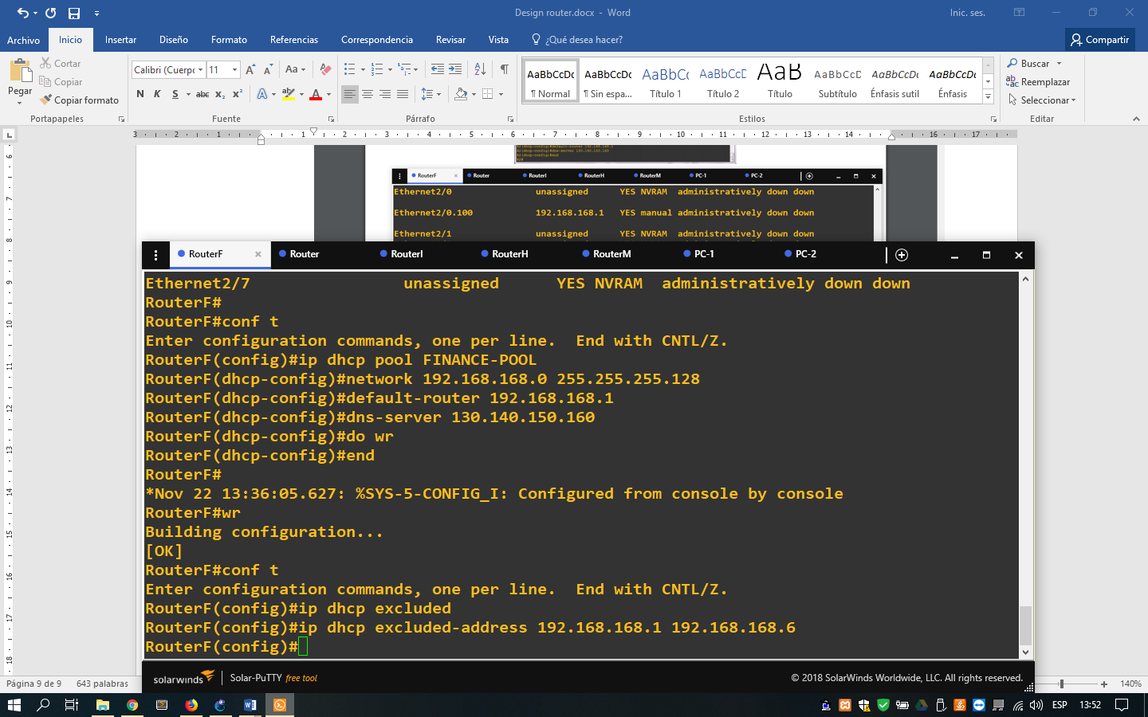

1. Command lines for configure a pool of DHCP
2. Command line for excluded IP address of the DHCP

For check this configuration, since a host console we can typing DHCP for assignment a IP address to the host

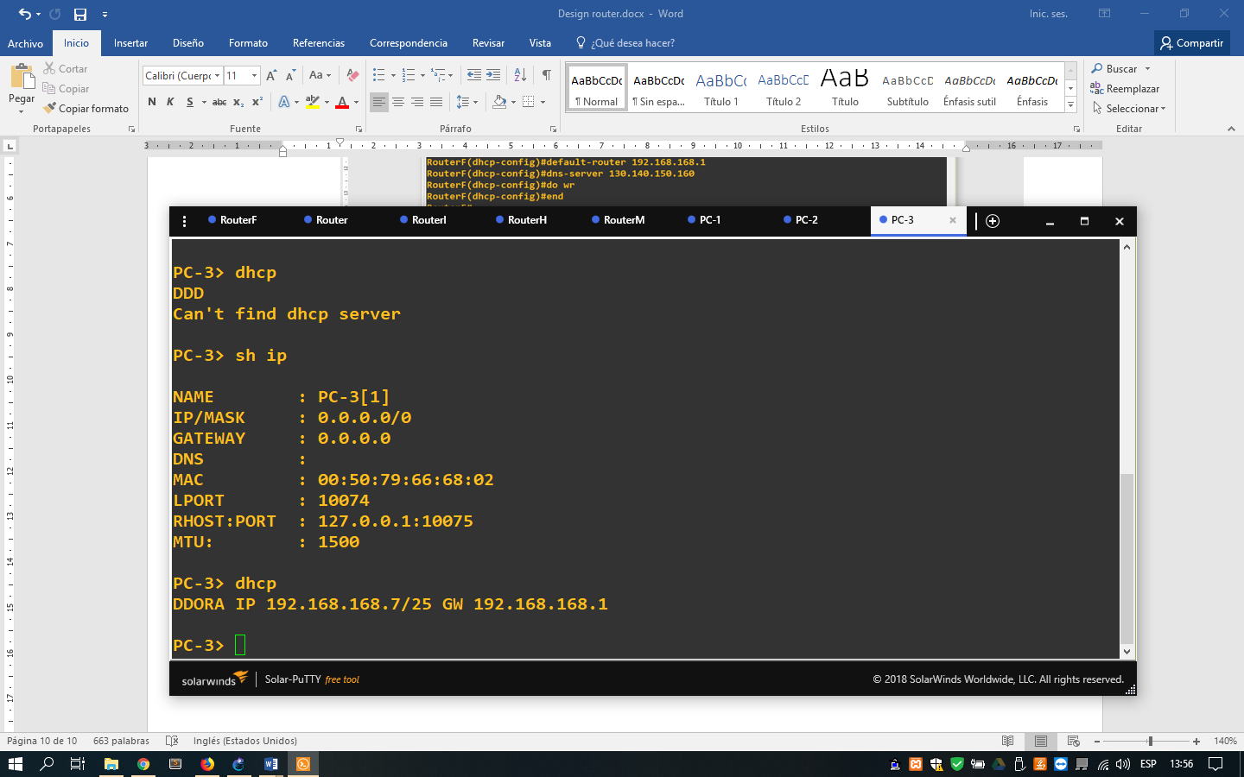

1. Command line for configure an IP address automatically in the host

If we make a ping to the main router, we are going to have an error of the communication due to that the router doesn't know where send it.

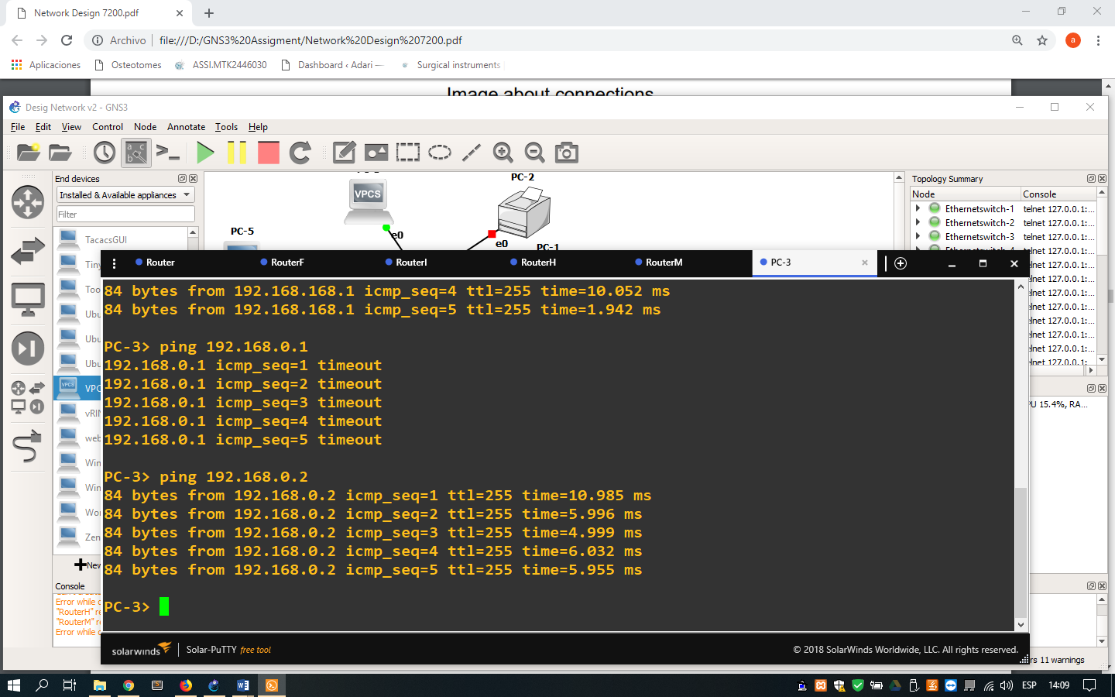

1. command lines doing ping to the routers

For avoid this, we configure static routes of the next command lines inside of the main router:

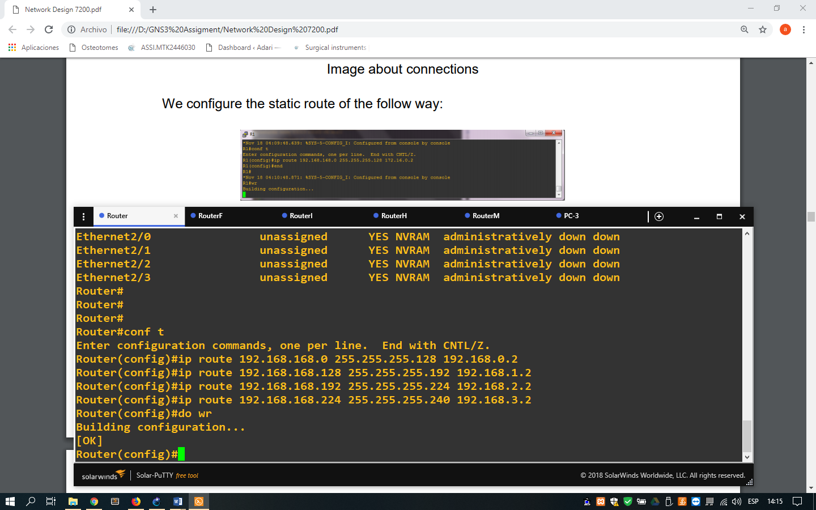

1. Command lines for configure static routes inside of the main router

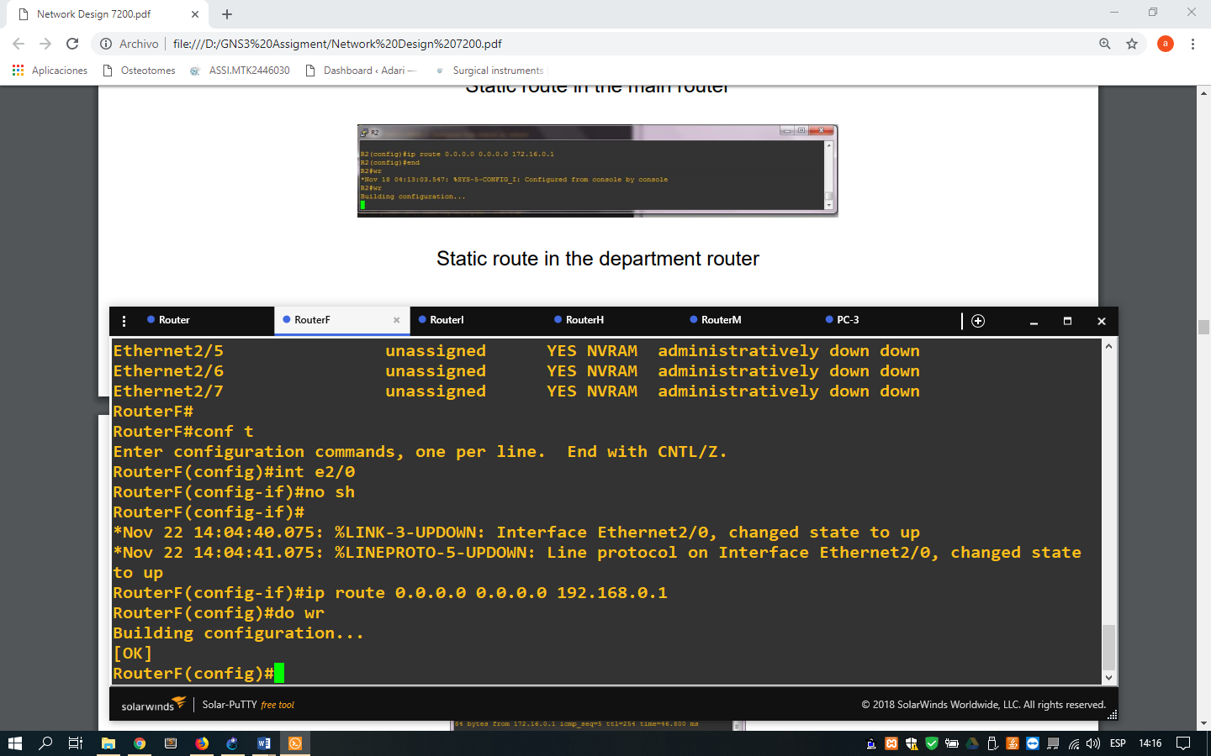

1. Command lines for configure the static route inside of the router of the department

After the realized the configuration, we check that the routing is success doing ping to the gateway

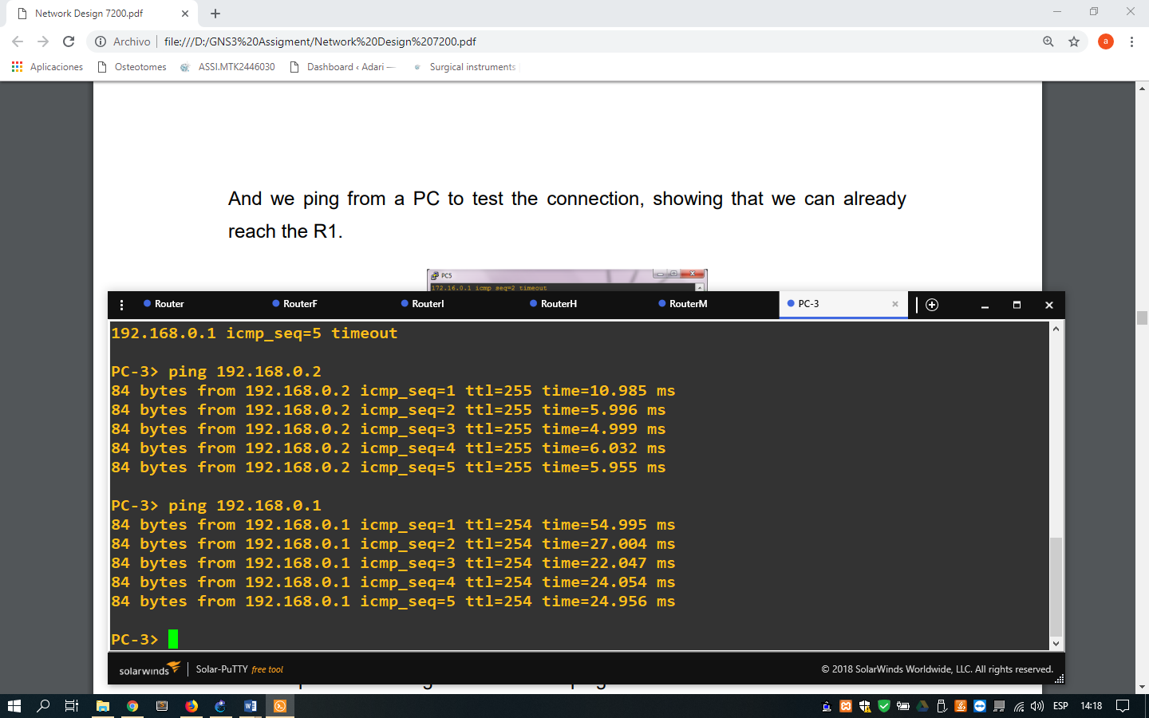

1. Command lines for check the success communication

Now for avoid the communication between the departments but having connection to the internet, we will create the access list inside of the router of the department of the next way:

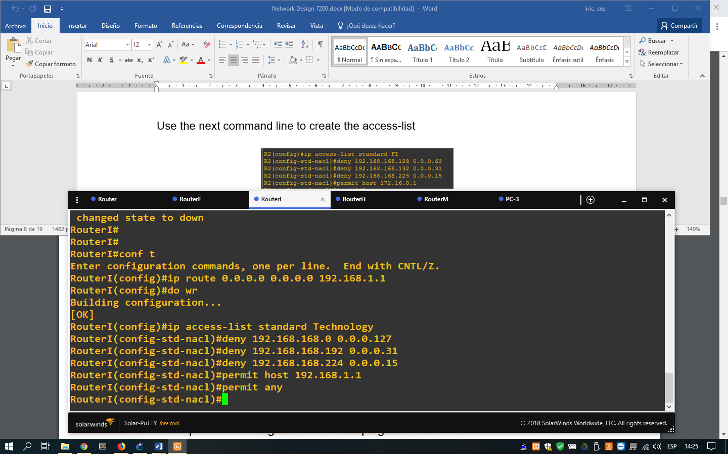

1. Command lines for create the access list

And we assignment the list in each port of the interfaces

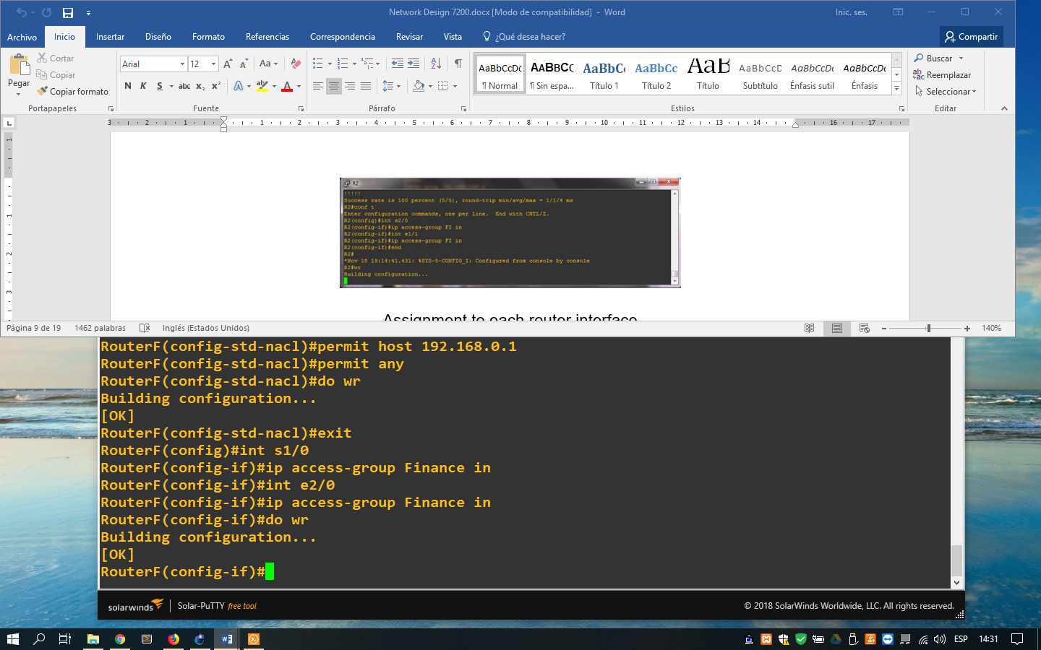

1. Command lines for assign the access list

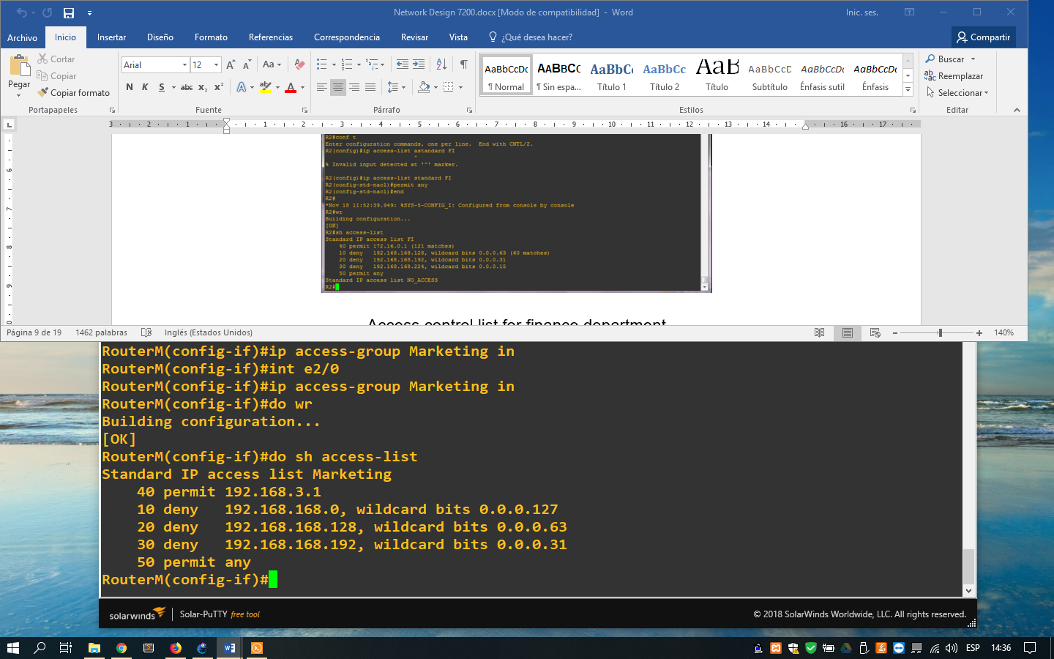

1. View of the access list configured

Now we can configure the DNS server our network of the next way:

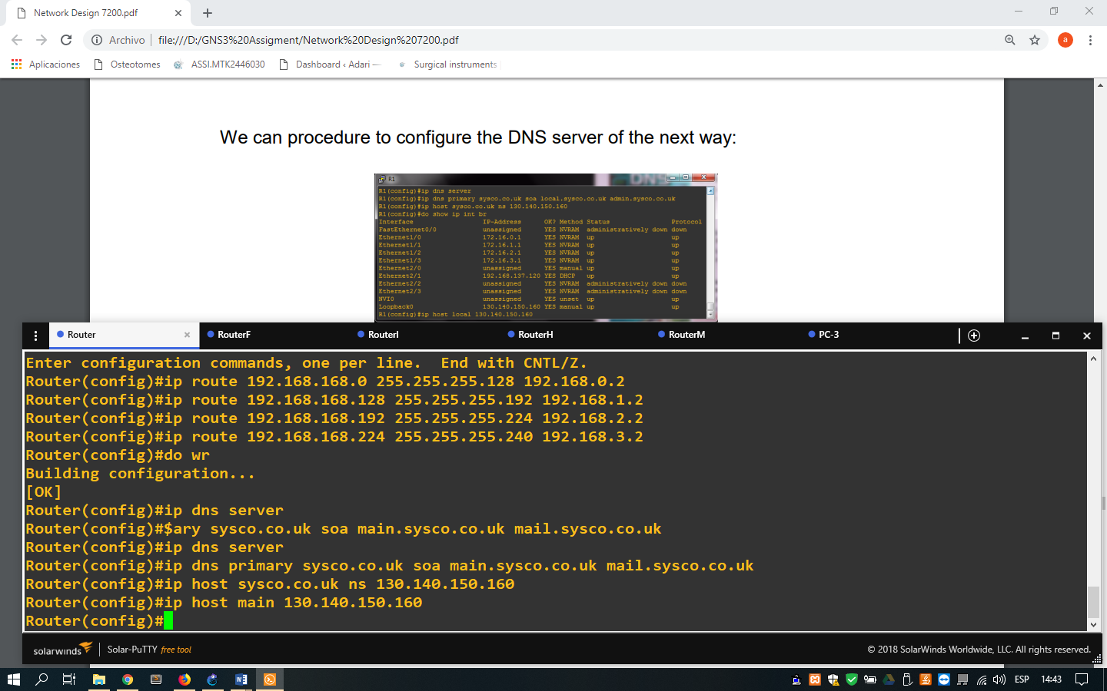

1. Command lines for configure the DNS server inside the main router

For each department router, the configuration is the next

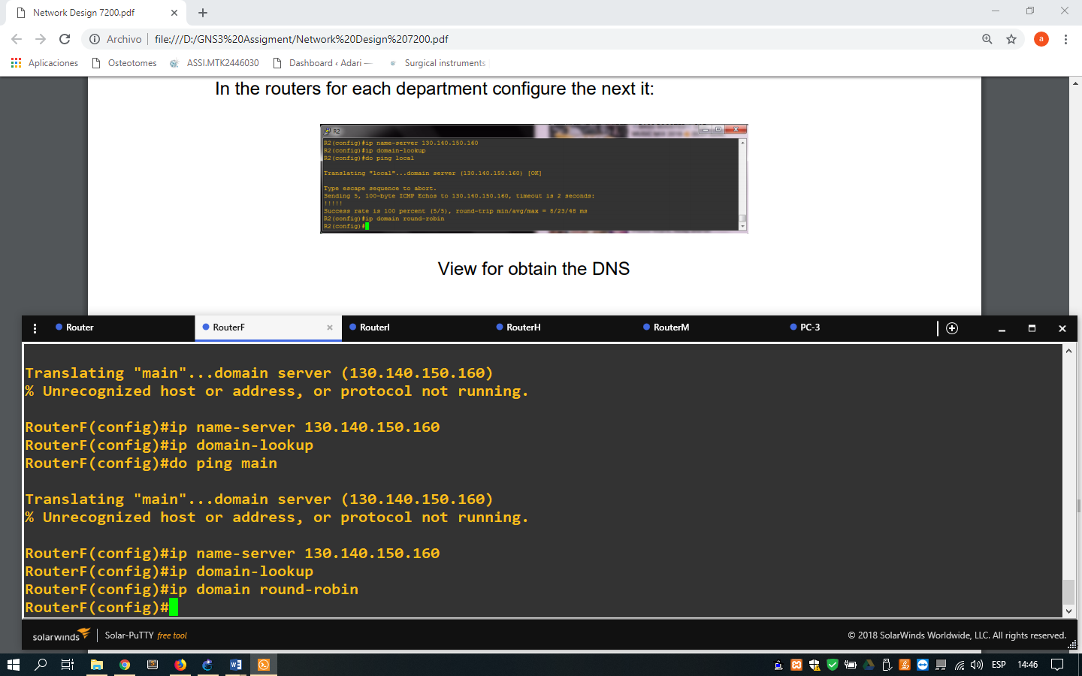

1. Command lines for configure the DNS inside the router of the department

For search an internet connection, we have to configure a loopback interface to be to provide of internet through our internet adapter. The configuration dependent of the operating system that we use.

For connect inside our network design, drag a cloud and we configure it selecting the interface of Loopback for the connection.

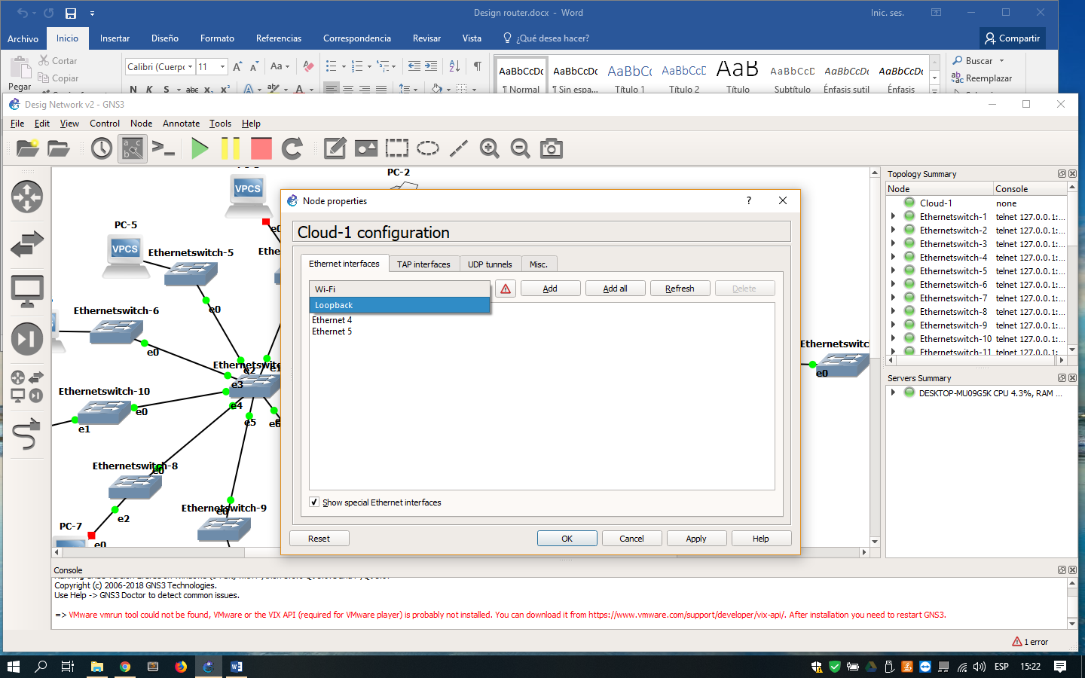

1. Window for configure the loopback interfaces in our cloud

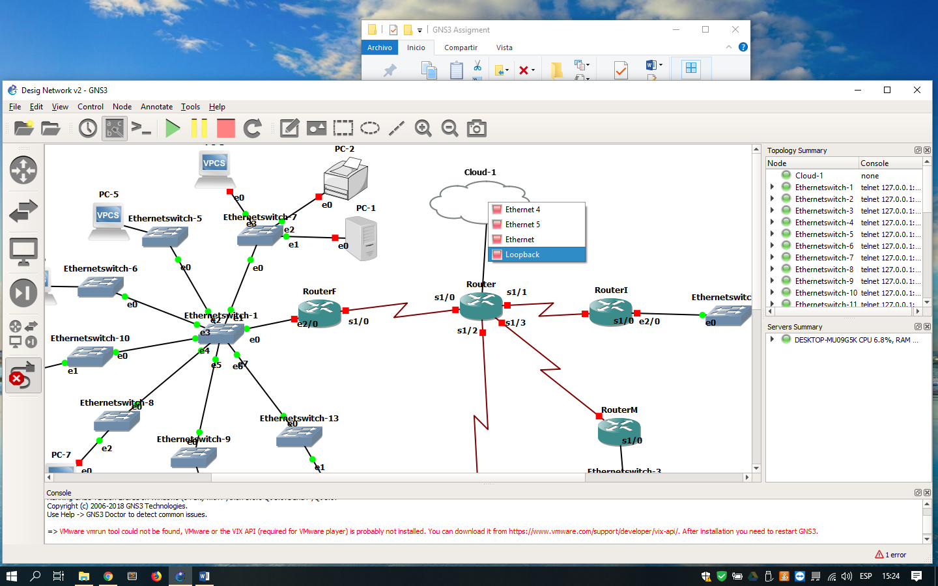

1. Connection from the main router until the cloud through loopback interface

Next, we request a IP address external with the next command

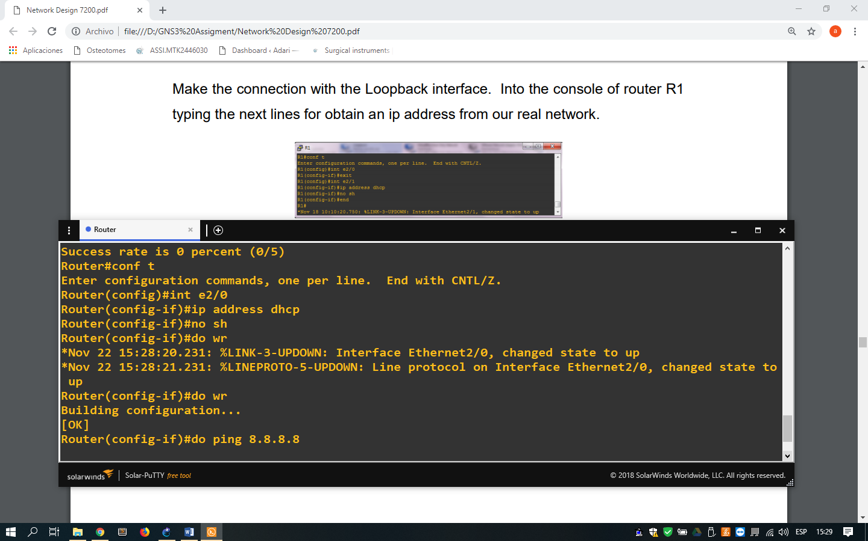

1. Request of the IP address for obtain access to internet

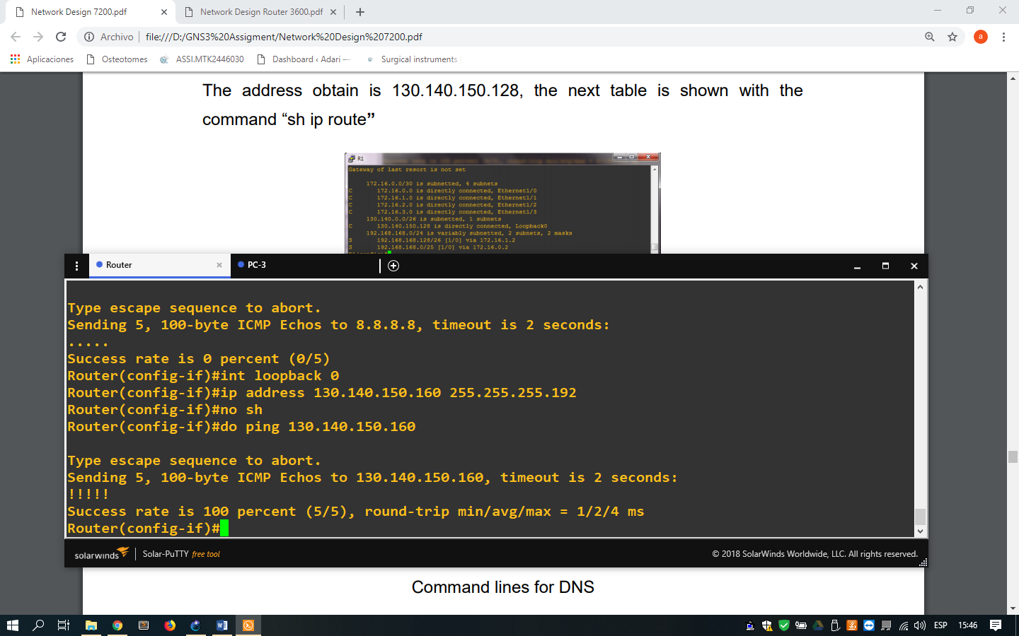

1. Command lines for create a loopback interface inside the main router

And for the other devices obtain access to the internet, we will configure NAT (Network Address Translation) inside the main router defining which are the inside channel and the outside channel with the next command lines:

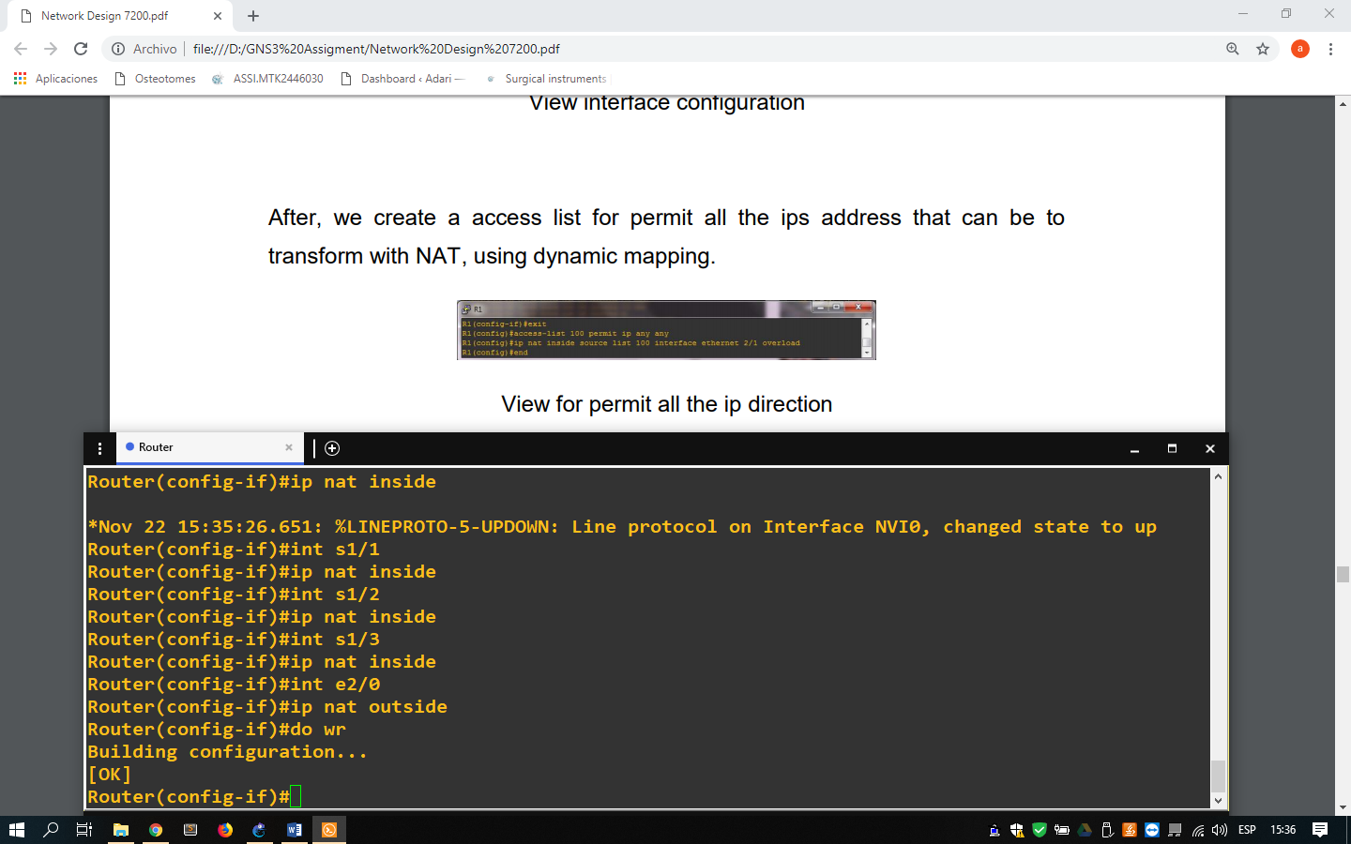

1. Command lines for configure the NAT inside the main router

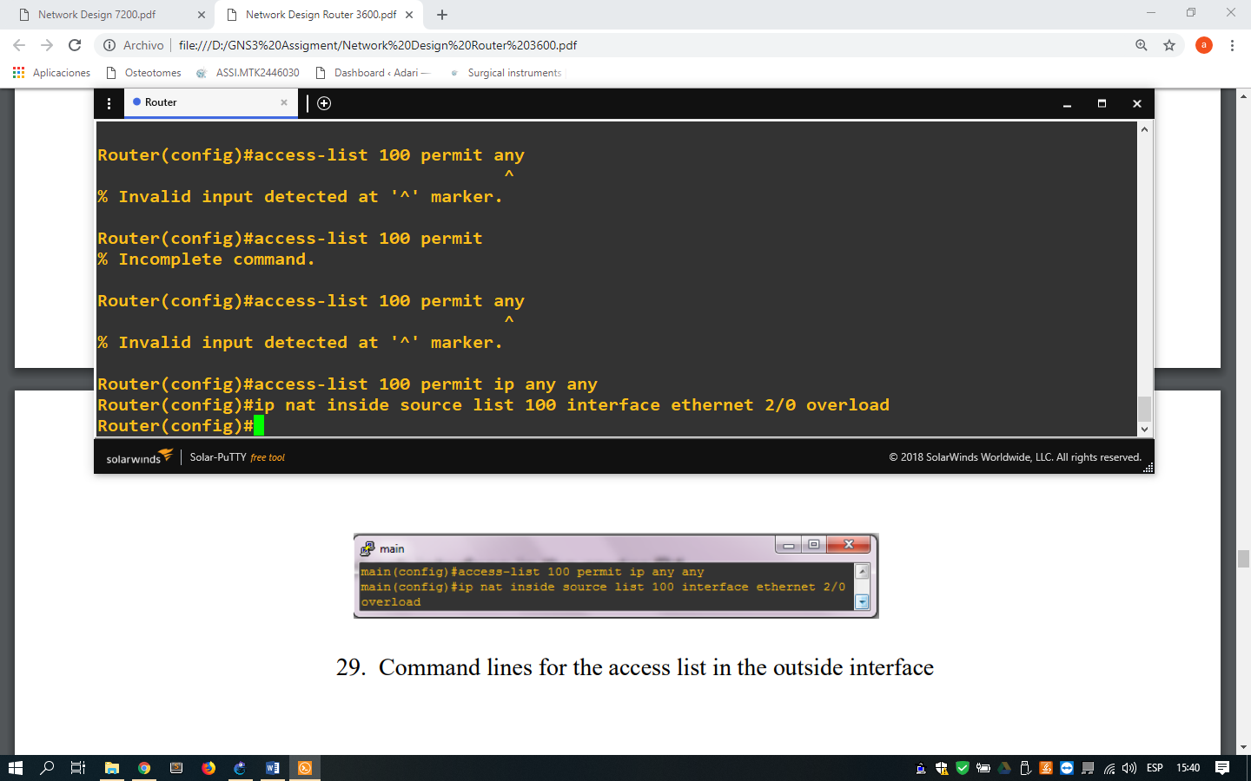

1. Command lines for create an access list for the outside interface

For the authentication, we use the PAP method between the routers of our WAN.

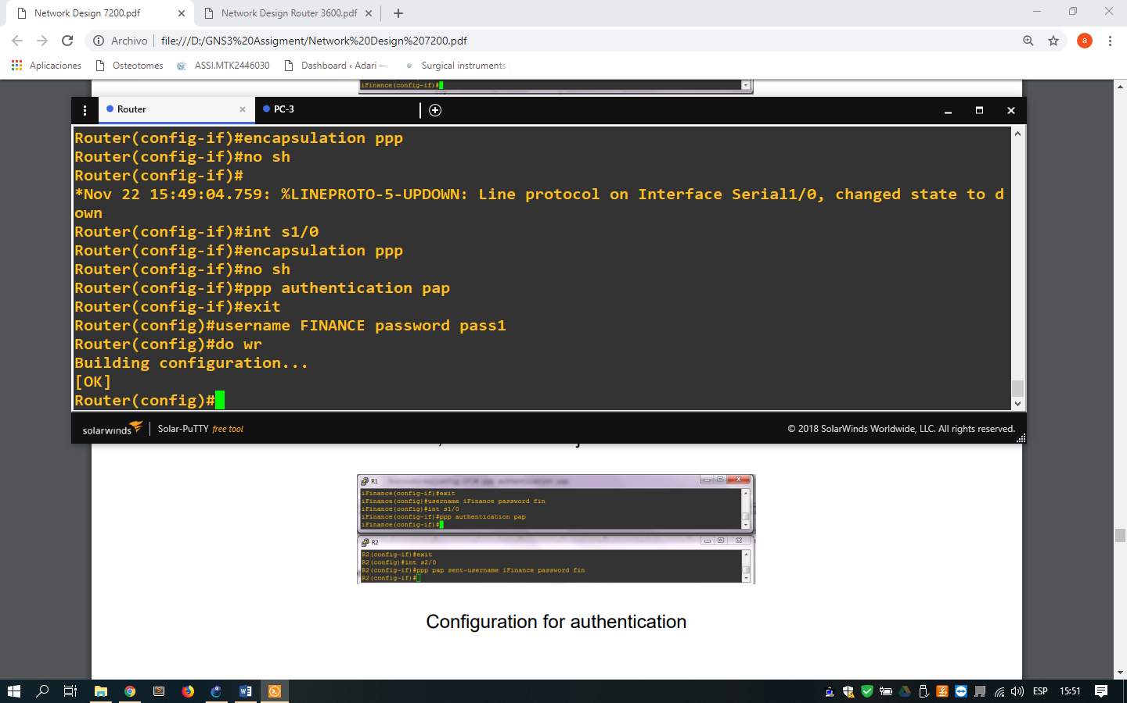

1. Command lines for configure the methods of authentication inside of the main router

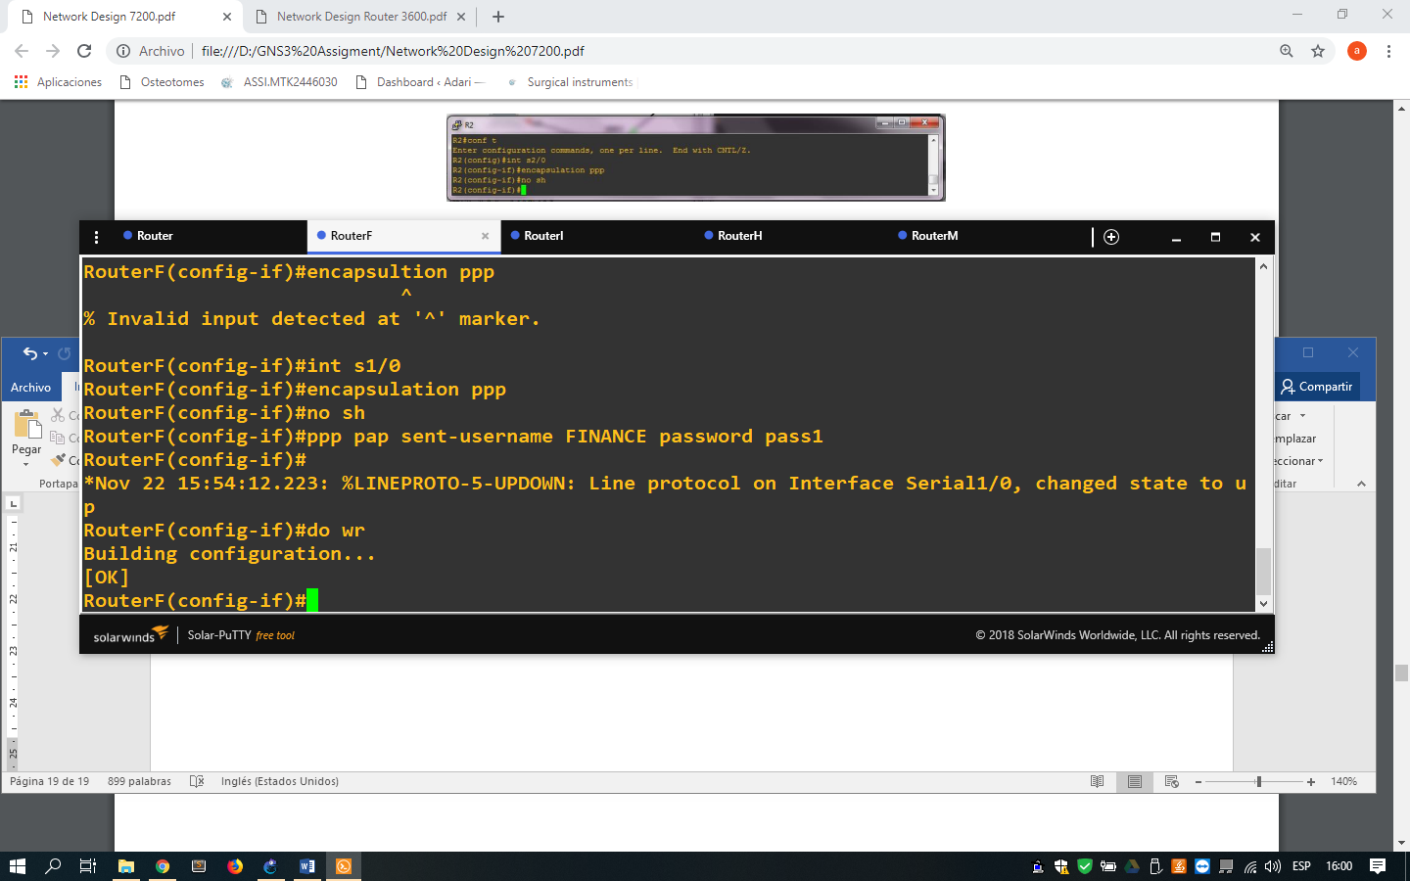

1. Command lines for configure the methods of authentication inside of the routers secondary

In the follow images, we can see the communication of a host localized in the Human Resource Department.

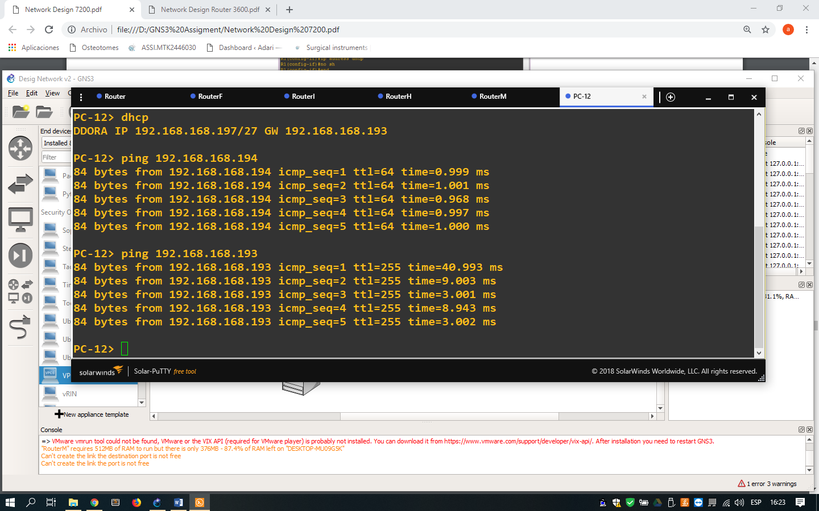

1. Command lines for check the communication inside its network

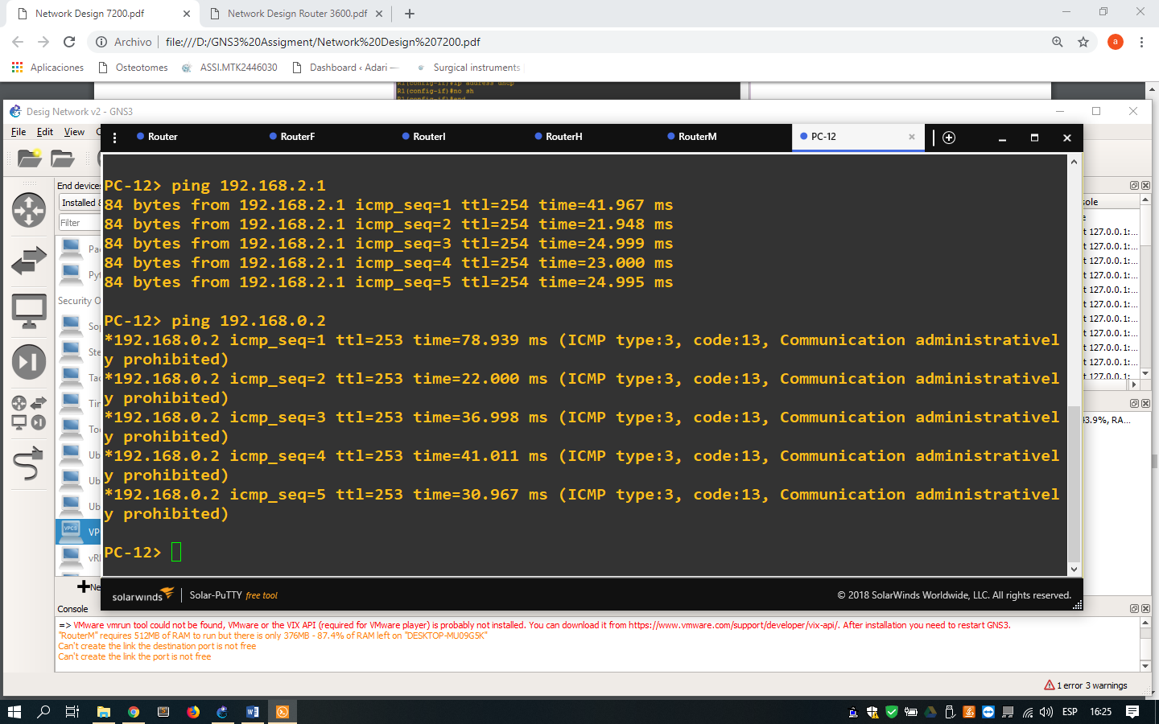

1. Command lines for check the communication with other points in the network

**REFERENCES**

* gns3vault.com,(2018). GNS3 VAULT *Official Website*. [online] Available at: https://gns3vault.com /[Accessed Nov. 2018]
* gns3.com,(2018). *Documentation GNS3 Official Website.* [online] Available at: https://docs.gns3.com/[Accessed Nov. 2018]
* cisco.com, (2018). *Configure Commonly Used IP ACLs*. Available at: <https://www.cisco.com/c/en/us/support/docs/ip/access-lists/26448-ACLsamples.html>[Accessed Nov. 2018]
* gns3.com, (2018). *Connect GNS3 to the Internet (local server)*. Available at: <https://docs.gns3.com/1vFs-KENh2uUFfb47Q2oeSersmEK4WahzWX-HrMIMd00/index.html> [Accessed Nov. 2018]
* smartpctricks.com, (2014). *How to Calculate Idle PC Value in GNS3 Network Simulator 0.8.6?*. Available at: <http://www.smartpctricks.com/2014/05/calculate-idle-pc-value-in-gns3.html>[Accessed Nov. 2018]